|  |  |
| --- | --- |
| Document Background Images, HD Pictures and Wallpaper For Free Download |  Pngtree **Food Choice**    **Faculty** = Miss Sana Sheeraz  **Batch code** = 2011 G3  **Curriculum**= 6673,  **Semester**= HDSE II,  C:\Users\asp\Desktop\123.png  APTECH NORTH NAZIMABAD  http://www.aptechnn.com | group members & enrolment no.  **HAFIZ MUHMMAD HAMZA (Student1287890) ABDUR RAFAY KHAN**  **(Student1287896)**  **ABU HURAIRA KHAN**  **(Student1274240)** |

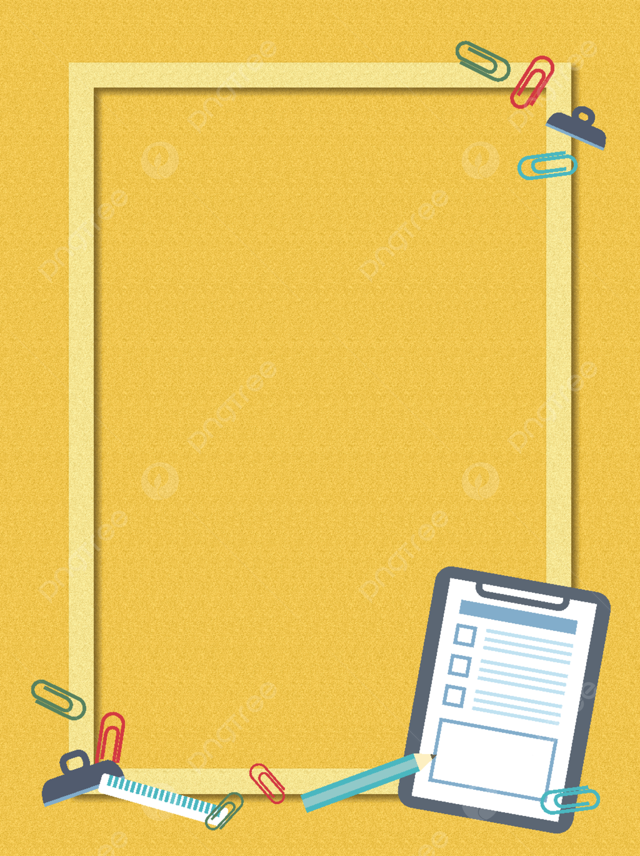**TABLE OF CONTENTS:**

ACKNOWLEDGEMEN 3

Abstract 4

**Declaration** 4

PROJECT CERTIFICATION: 5

Introduction 6

Problem Statement 6

Conclusion 6

**Objective** 8

**PROJECT MAKING** 9

**Project duration** 9

**Task sheet** 10

SOFTWARE & HARDWARE REQUIREMENTS 11

**Hardware Requirements:** 11

**Software Requirements:** 11

WORKFLOW 12

**APPLICATION MAP** 13

**SCREENSHOT** 14

• **Login** 15

• **Admin Panel.** 16

• **ingrediants** 17

• **add recipe** 19

• **category** 20

• **meal planner** 21

• **sign up** 23

ACKNOWLEDGEMENT

**W**

e are thankful to Almighty, ALLAH that by His grace we have been successful. We presenting on **Android Studio** in your hands. We have tried our best to take all relevant important topics in consideration so that this project may become comprehensive.

This is our **fourth Semester** project. We have tried our best & struggled for a better outlook to come. This project has been developed in **Android Studio.** We choose to make Desktop Application for **Food Choice** as a project. We find easy to do coding in **Android Studio.**

We earnestly hope that this project will provide all the necessarily information required for the user to fulfill their inspiration. However, suggestions for improvement of the project will be thankful received & acknowledge.

It was very great experience for us to make the android app application in **Android** **studio**.

**Thanking Y****ou!**

**ABSTRACT**

The topic of our project was to develop a ***FOOD CHOICE***

It’s made using **ANDROID STUDIO AND DATABASE WITH USING FIREBASE**.

## **Declaration**

We are writing this to declare that all the work which is being written bellow in this Project Report entitled “—***ANDROID STUDIO*** --” is a veritable record of our own work submitted to the Aptech NN, Karachi, Pakistan during the year ***2022*** to ***2023*** in the partial fulfillment of ***semester iv*** (***HDSE II***) project We also declare that we have not submitted the material being presented in this Project Report for the award of any other degree elsewhere

## 

# Document Background Images, HD Pictures and Wallpaper For Free Download | Pngtree**PROJECT CERTIFICATION:**

***FOOD CHOICE***

This is to certify that,

***Hafiz Muhammad Hamza (Student1287890)***

***Abdur Rafay Khan (Student1287896)***

***Abu Huraira Khan (student1274240 )***

has successfully Designed & Developed ***FOOD CHOICE***

Date of Issue: **28-Nov-2022**

Date of Submission: **2-Dec -2023**

Authorized Signature**: *Miss Sana Sheeraz***

# Document Background Images, HD Pictures and Wallpaper For Free Download | Pngtree**introduction**

### Problem Statement

# ***food choice***

**The main aim of developing this Android-based mobile Carve your Choice Food App is to**

**provide easy food application to the users those who want to explore tasty food in their**

**kitchen. This app can be helpful to the newcomers to prepare delicious food.**

**EXISTING SOLUTION**

**• Displays only recipe description by selecting the particular recipe**

**• only shows grocery items**

**• individual details of each ingredient**

**PROBLEM**

**• Many people want to do a variety of recipes in their homes.**

**• Some people may have a habit of preparing a variety of cuisines in their homes and**

**they try to browse and cook.**

**• Here there is a problem arises of ingredients, some may be available may not be**

**available and it takes more time to search and can’t find nutrition facts directly.**

**DISADVANTAGES OF EXISTING SOLUTION**

**• Manually typing about the items**

**• Doesn’t show each and every detail of vegetables**

**• It requires more time to search for recipes.**

**PROPOSED SYSTEM**

**We are going to provide a Carve your Choice Food App for different ingredients like organic**

**food and inorganic food materials with their use cases and also we are linking up with**

**videos so that everyone can access easily**

**ADVANTAGES OF PROPOSED SYSTEM**

**• Time-saving, Conduit-free setup, and maintenance**

**• Ease of Use and Implementation**

**• It is useful for bachelors**

**• The people who don’t know cooking**

**• It can show the diet details so that we can follow healthy tips**

**Software Requirements:**

**Language:** JAVA

**Database:** FIRE BASE

**Software:** ANDROID STUDIO

Diploma in Information Systems Management (DISM)

**Conclusion:**

As our food-related idea is useful for a number of people we are providing features for

literate and illiterate people so that the person can easily understand and they can prepare

any type of recipe using this app and can learn the easy way of cooking with their available

items.

# Document Background Images, HD Pictures and Wallpaper For Free Download | Pngtree**PROJECTMAKING**

## Project Duration:

1. Analysis- 2 days
2. Design – 9 days
3. Development –13 days
4. Documentation -2days.

|  |  |  |  |  |
| --- | --- | --- | --- | --- |
| Analysis | Design | Database | Testing | Documentation |

|  |  |  |  |  |  |  |  |  |  |  |  |  |  |  |  |  |  |  |  |  |  |  |  |  |  |  |  |  |  |
| --- | --- | --- | --- | --- | --- | --- | --- | --- | --- | --- | --- | --- | --- | --- | --- | --- | --- | --- | --- | --- | --- | --- | --- | --- | --- | --- | --- | --- | --- |
| 1 | 2 | 3 | 4 | 5 | 6 | 7 | 8 | 9 | 10 | 11 | 12 | 13 | 14 | 15 | 16 | 17 | 18 | 19 | 20 | 21 | 22 | 23 | 24 | 25 | 26 | 27 | 28 | 29 | 30 |

## **Task sheet**

|  |  |  |  |
| --- | --- | --- | --- |
| **No.** | **Task** | Document Background Images, HD Pictures and Wallpaper For Free Download |  Pngtree**Teammates Name** | **Status** |
| 1. | Analysis | Hafiz Hamza | Completed |
| 2. | UI Designing | Hafiz Hamza  Abdur Rafay Khan | Completed |
| 3 | development | Hafiz Hamza | completed |
| 4. | Material Searching | Abu Huraira Khan  Hafiz Hamza  Abdur Rafay Khan | Completed |
| 5. | Database Connectivity | Hafiz Hamza | Completed |
| 6. | Documentation | Abdur Rafay khan | Completed |

# Document Background Images, HD Pictures and Wallpaper For Free Download | Pngtree**Software & Hardware Requirements**

## **Hardware Requirements:**

Android mobile with a minimum version 2.2.

The processor is not less than 500MHZ.

RAM is not less than 2048MB.

SD card with a minimum of 512MB.

Resolution is not less than 480*800pixs.

## **Software Requirements:**

Use software as per your requirement

Windows OS/JAVA/Android SDK/Notepad/SQL/Android 2.2 or Later

Admin Panel

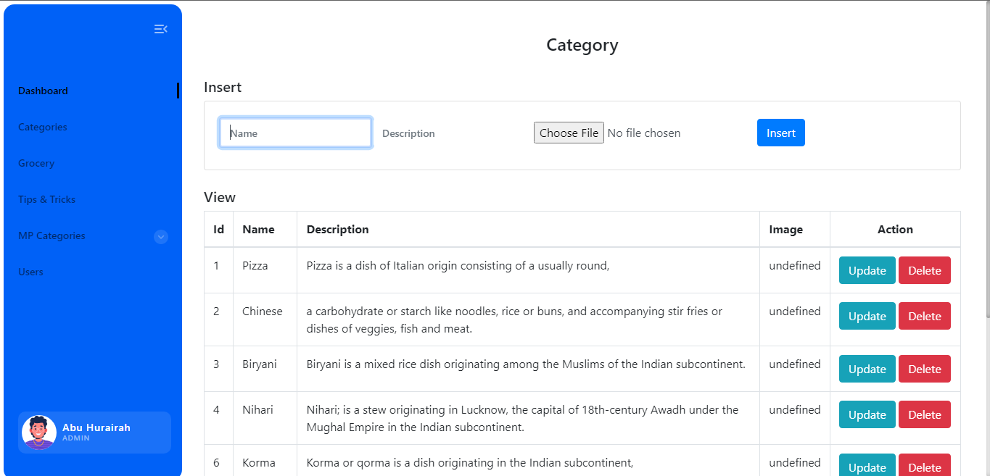

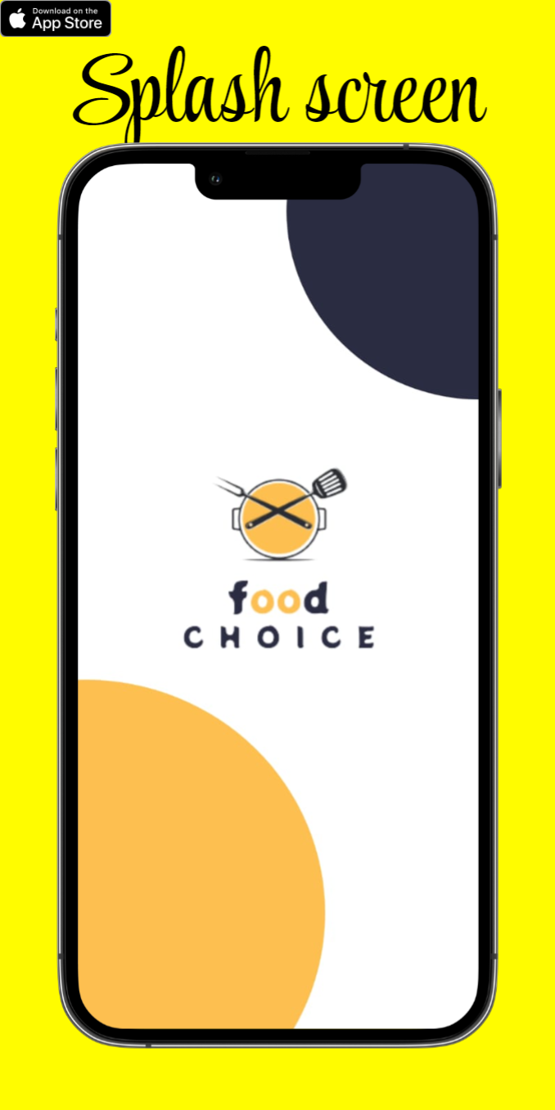



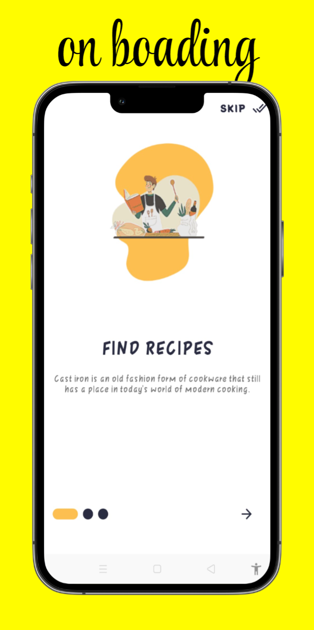

w



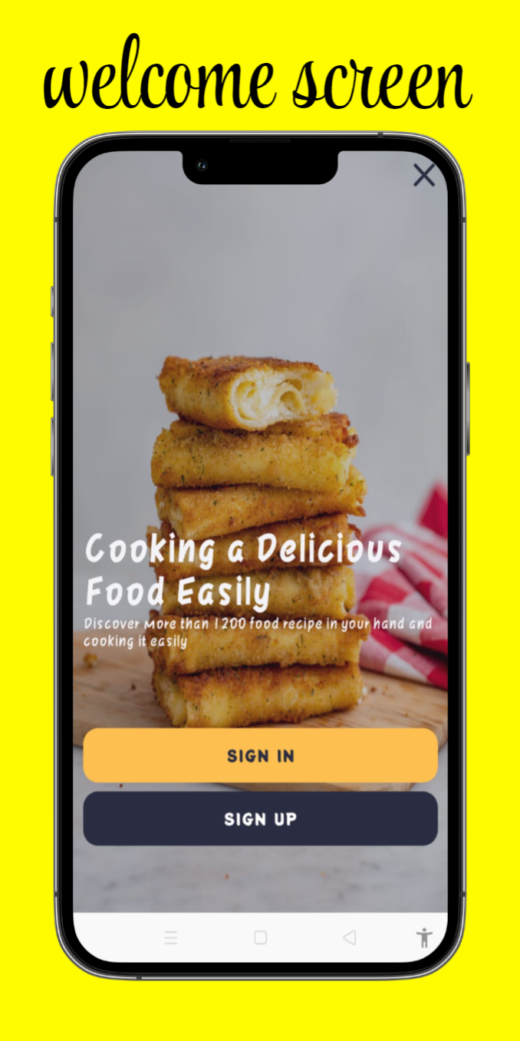

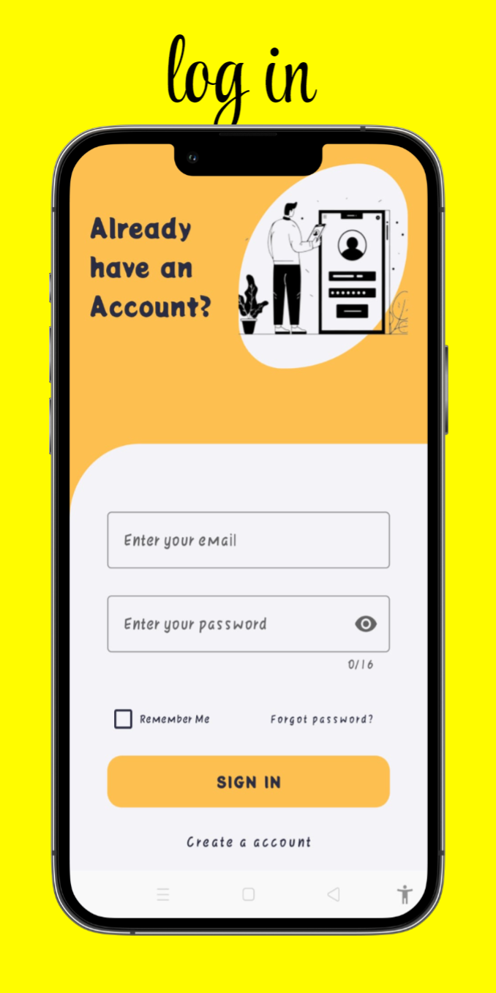



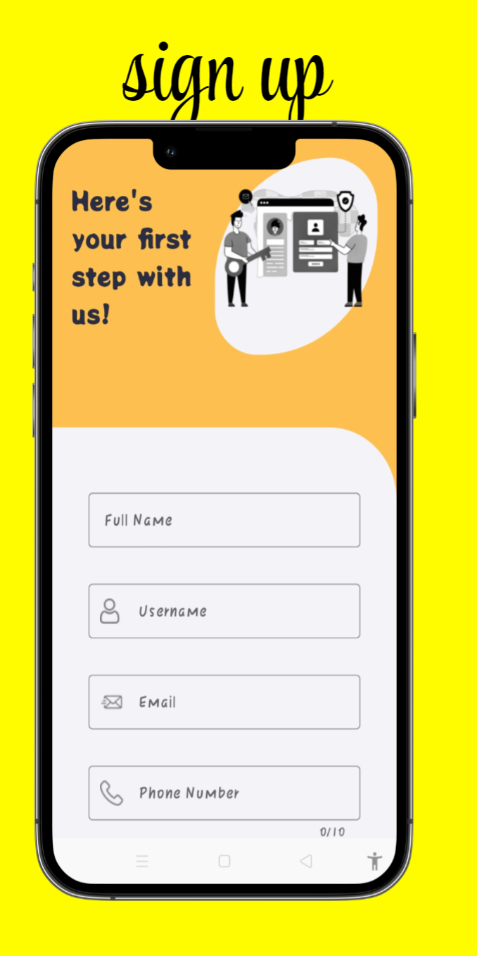



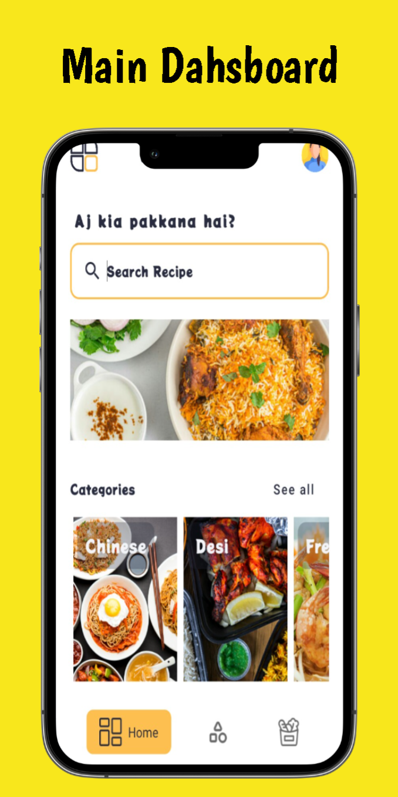



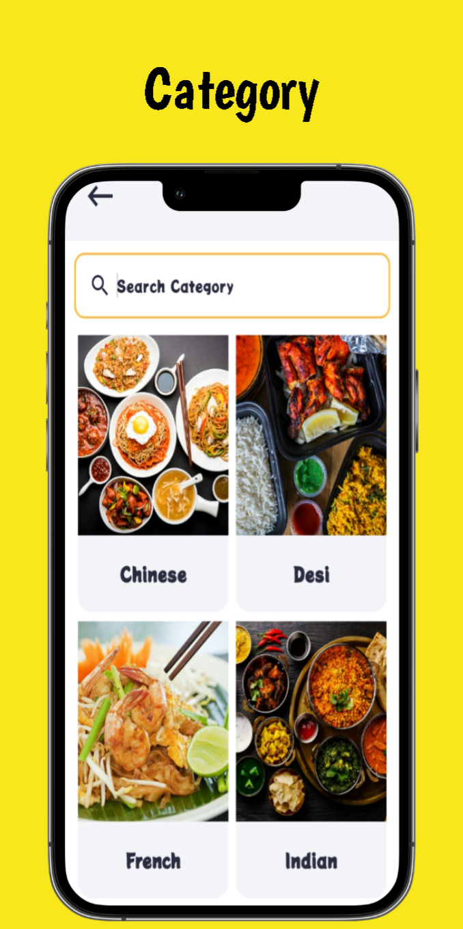

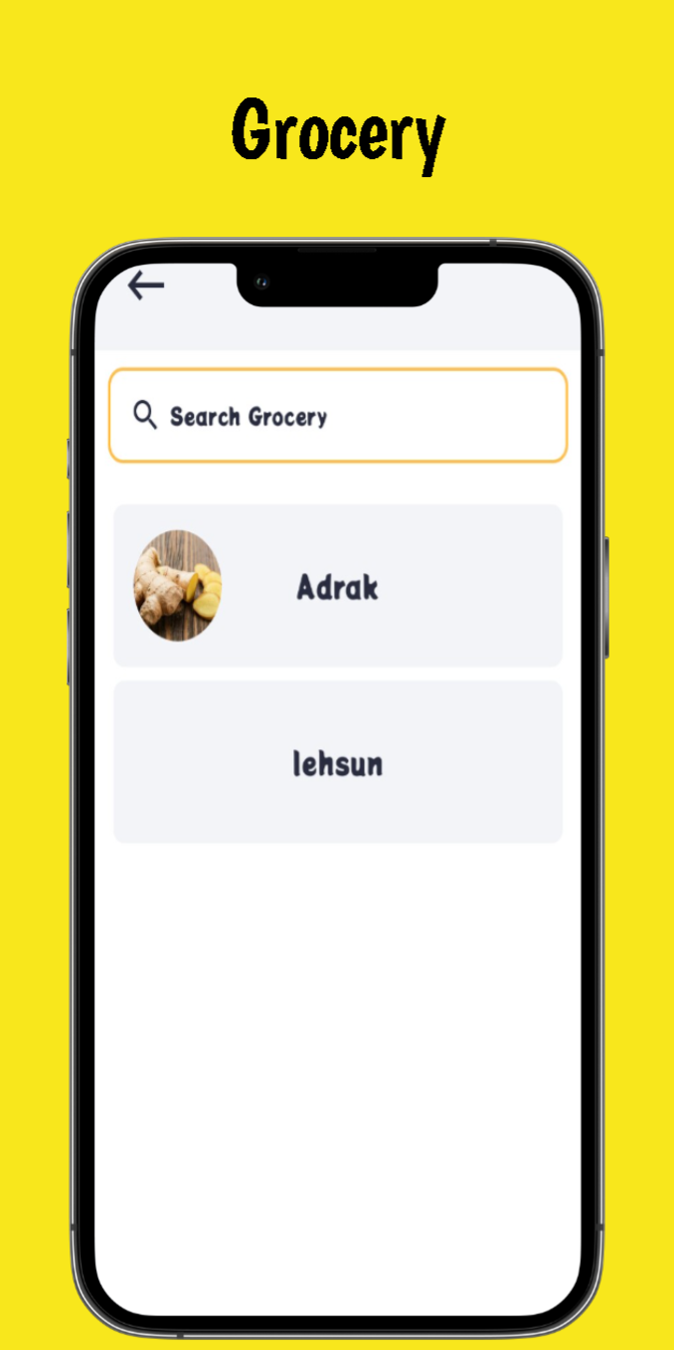



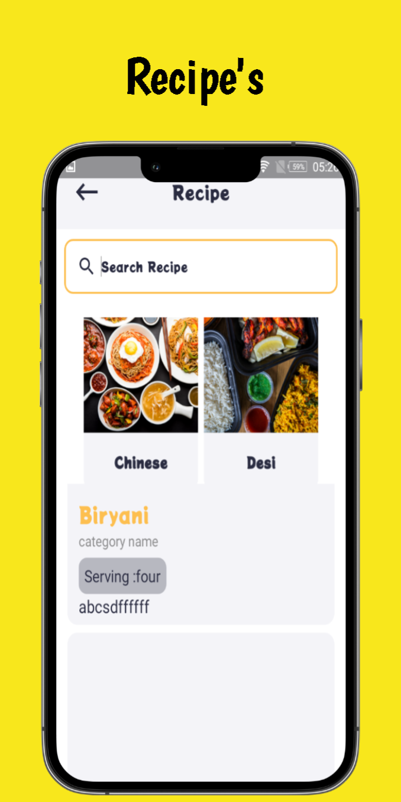



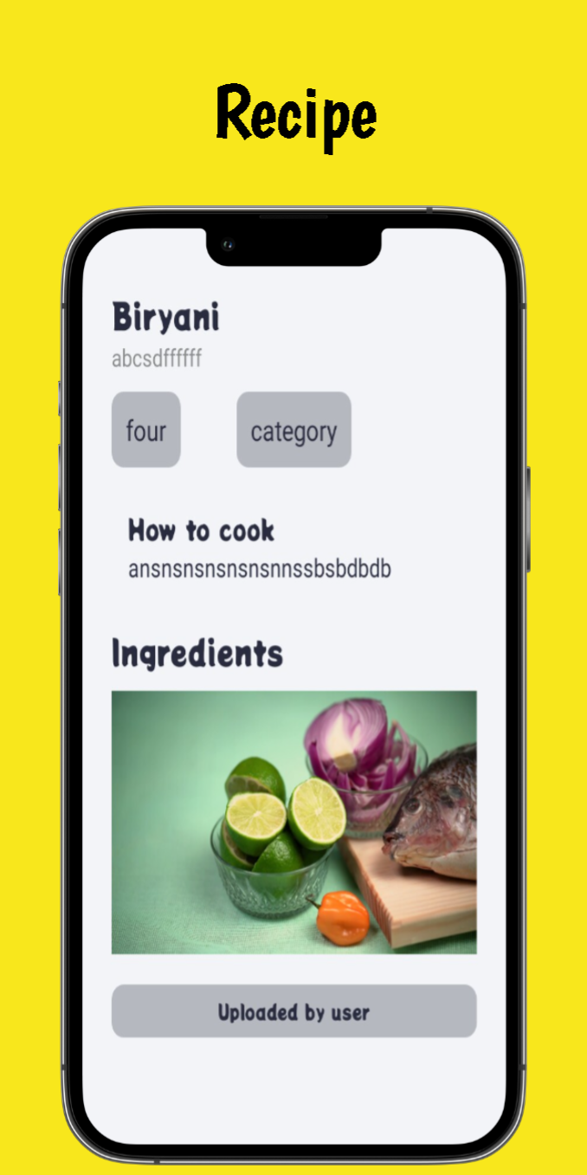



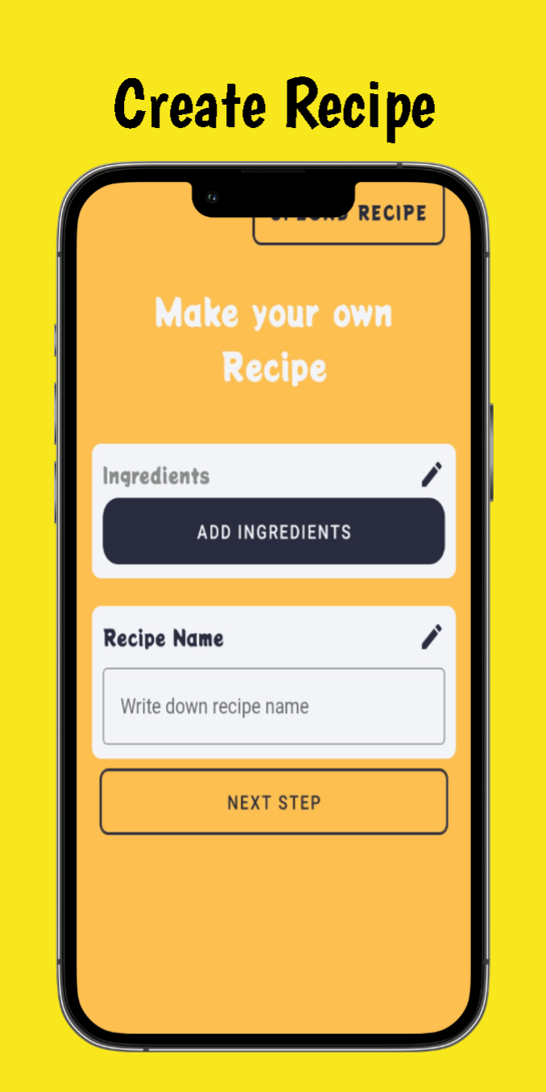



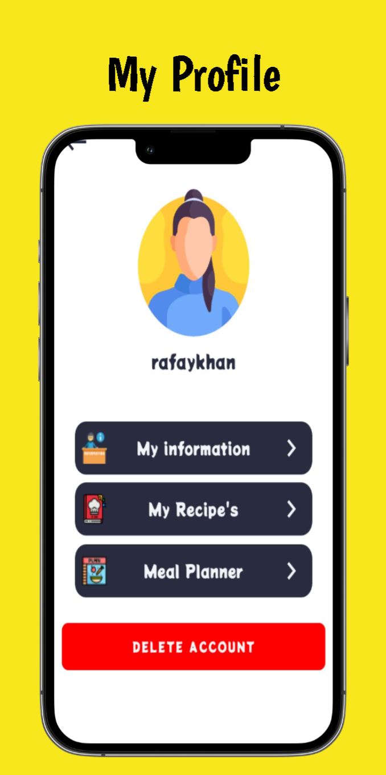

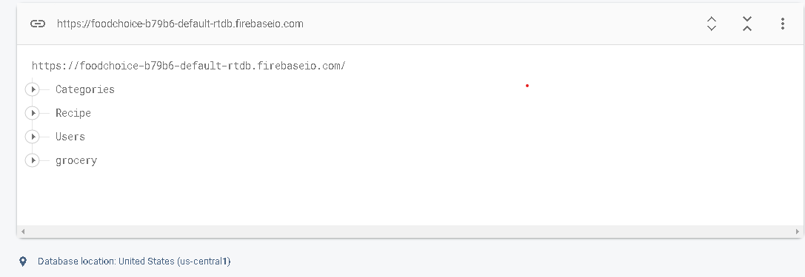

DATABASE HIERARCHY